**TUGAS KELOMPOK AP2B**

NAMA KELOMPOK 2 :  
1. Ahmad Fadhilah (50422120)

2. Athallah Rafi Yusnandar (50422287)

3. Aura Salsabila (50422301)

4. Fahru Rahman (50422490)

5. Febri Yanti (50422550)

6. Hamada Kemal Syauki (50422644)

7. Juan Wens Sacntung R (50422759)

8. Mohd Zimar Alwan (50422917)

9. Rizki Maulana Saputra (51422474)

10. Sulthan Haikal Rahman (51422556)

11. Windi Dwi Astuti (51422630)

LISTING

* 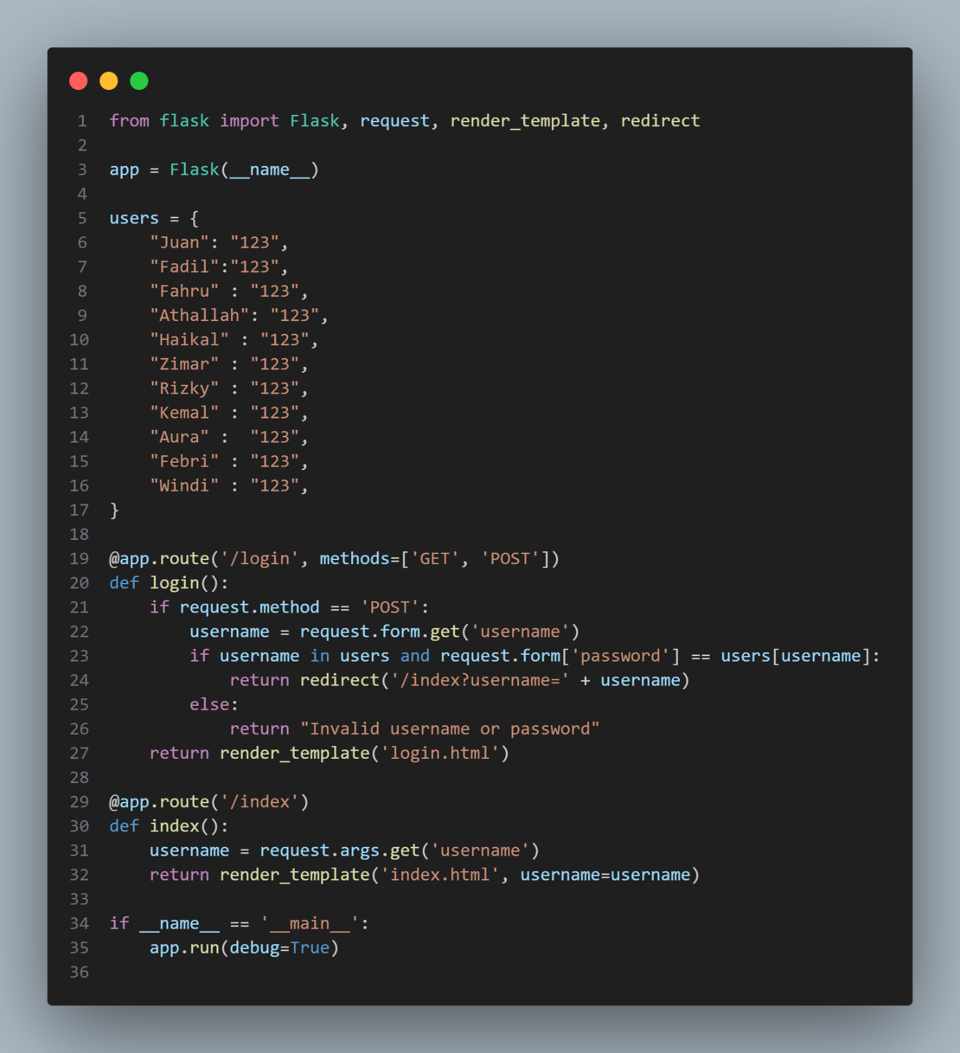KODINGAN 1

from flask import Flask, request, render_template, redirect

app = Flask(__name__)

users = {

"Juan": "123",

"Fadil":"123",

"Fahru" : "123",

"Athallah": "123",

"Haikal" : "123",

"Zimar" : "123",

"Rizky" : "123",

"Kemal" : "123",

"Aura" : "123",

"Febri" : "123",

"Windi" : "123",

}

@app.route('/login', methods=['GET', 'POST'])

def login():

if request.method == 'POST':

username = request.form.get('username')

if username in users and request.form['password'] == users[username]:

return redirect('/index?username=' + username)

else:

return "Invalid username or password"

return render_template('login.html')

@app.route('/index')

def index():

username = request.args.get('username')

return render_template('index.html', username=username)

if __name__ == '__main__':

app.run(debug=True)

* KODINGAN 2

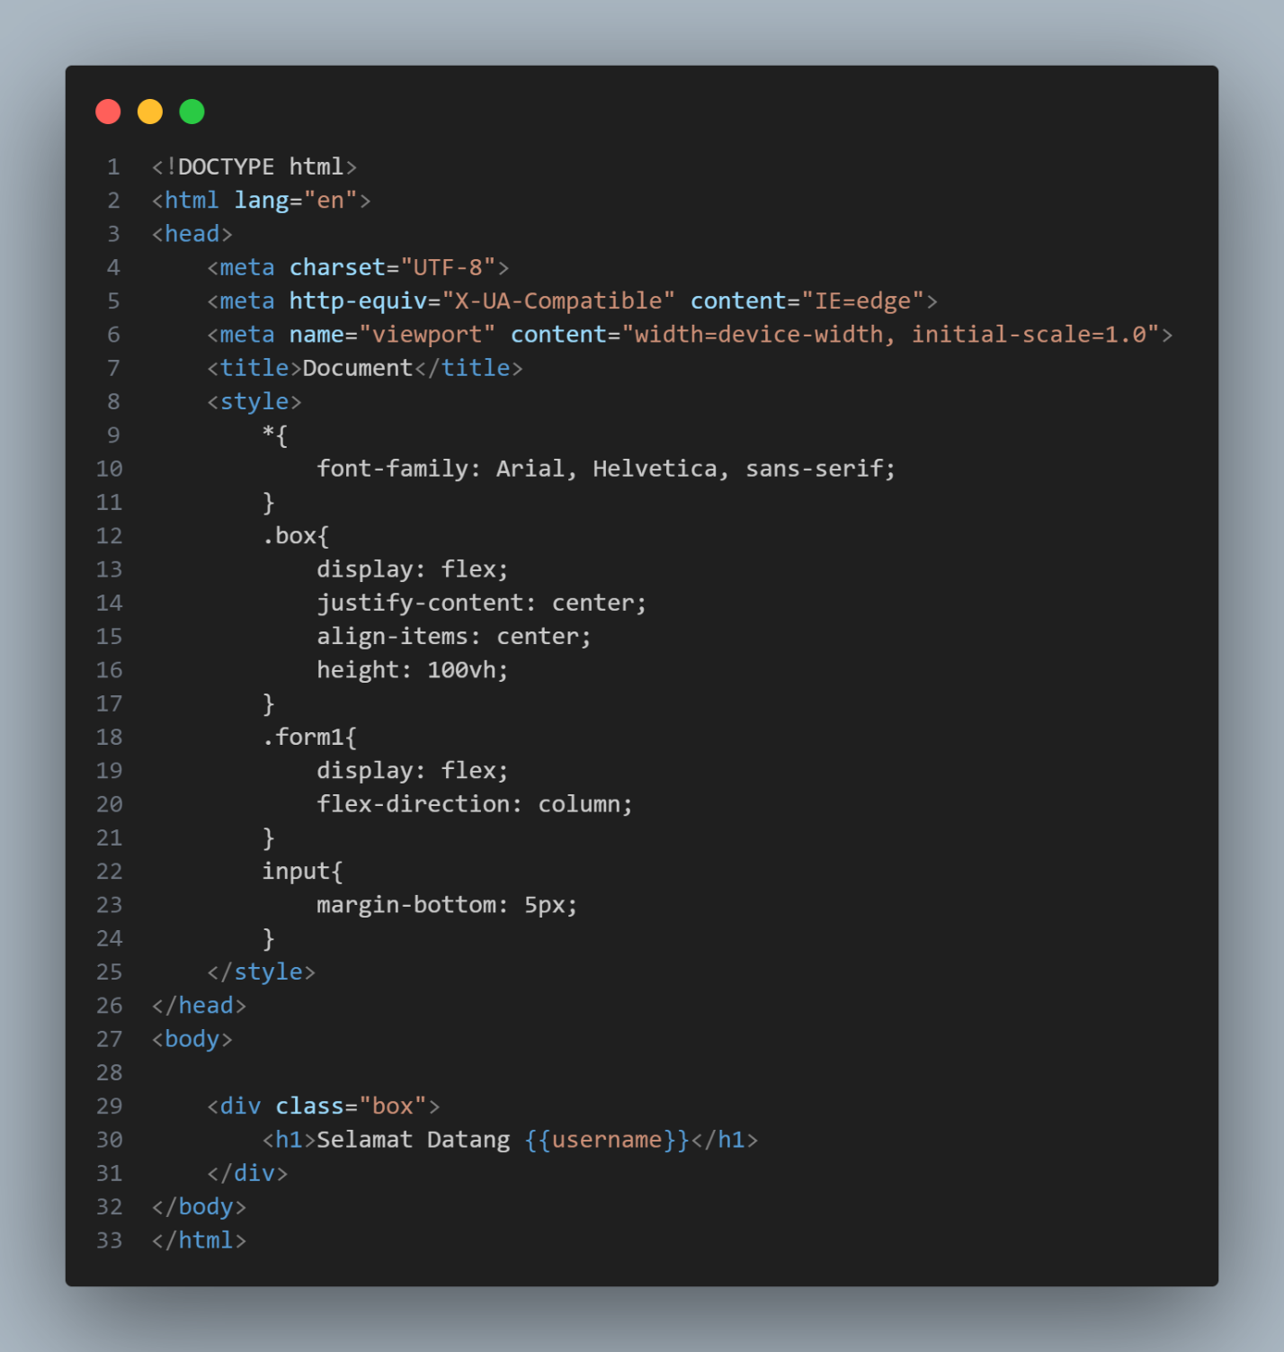

<!DOCTYPE html>

<html lang="en">

<head>

<meta charset="UTF-8">

<meta http-equiv="X-UA-Compatible" content="IE=edge">

<meta name="viewport" content="width=device-width, initial-scale=1.0">

<title>Document</title>

<style>

*{

font-family: Arial, Helvetica, sans-serif;

}

.box{

display: flex;

justify-content: center;

align-items: center;

height: 100vh;

}

.form1{

display: flex;

flex-direction: column;

}

input{

margin-bottom: 5px;

}

</style>

</head>

<body>

<div class="box">

<h1>Selamat Datang {{username}}</h1>

</div>

</body>

</html>

* KODINGAN 3

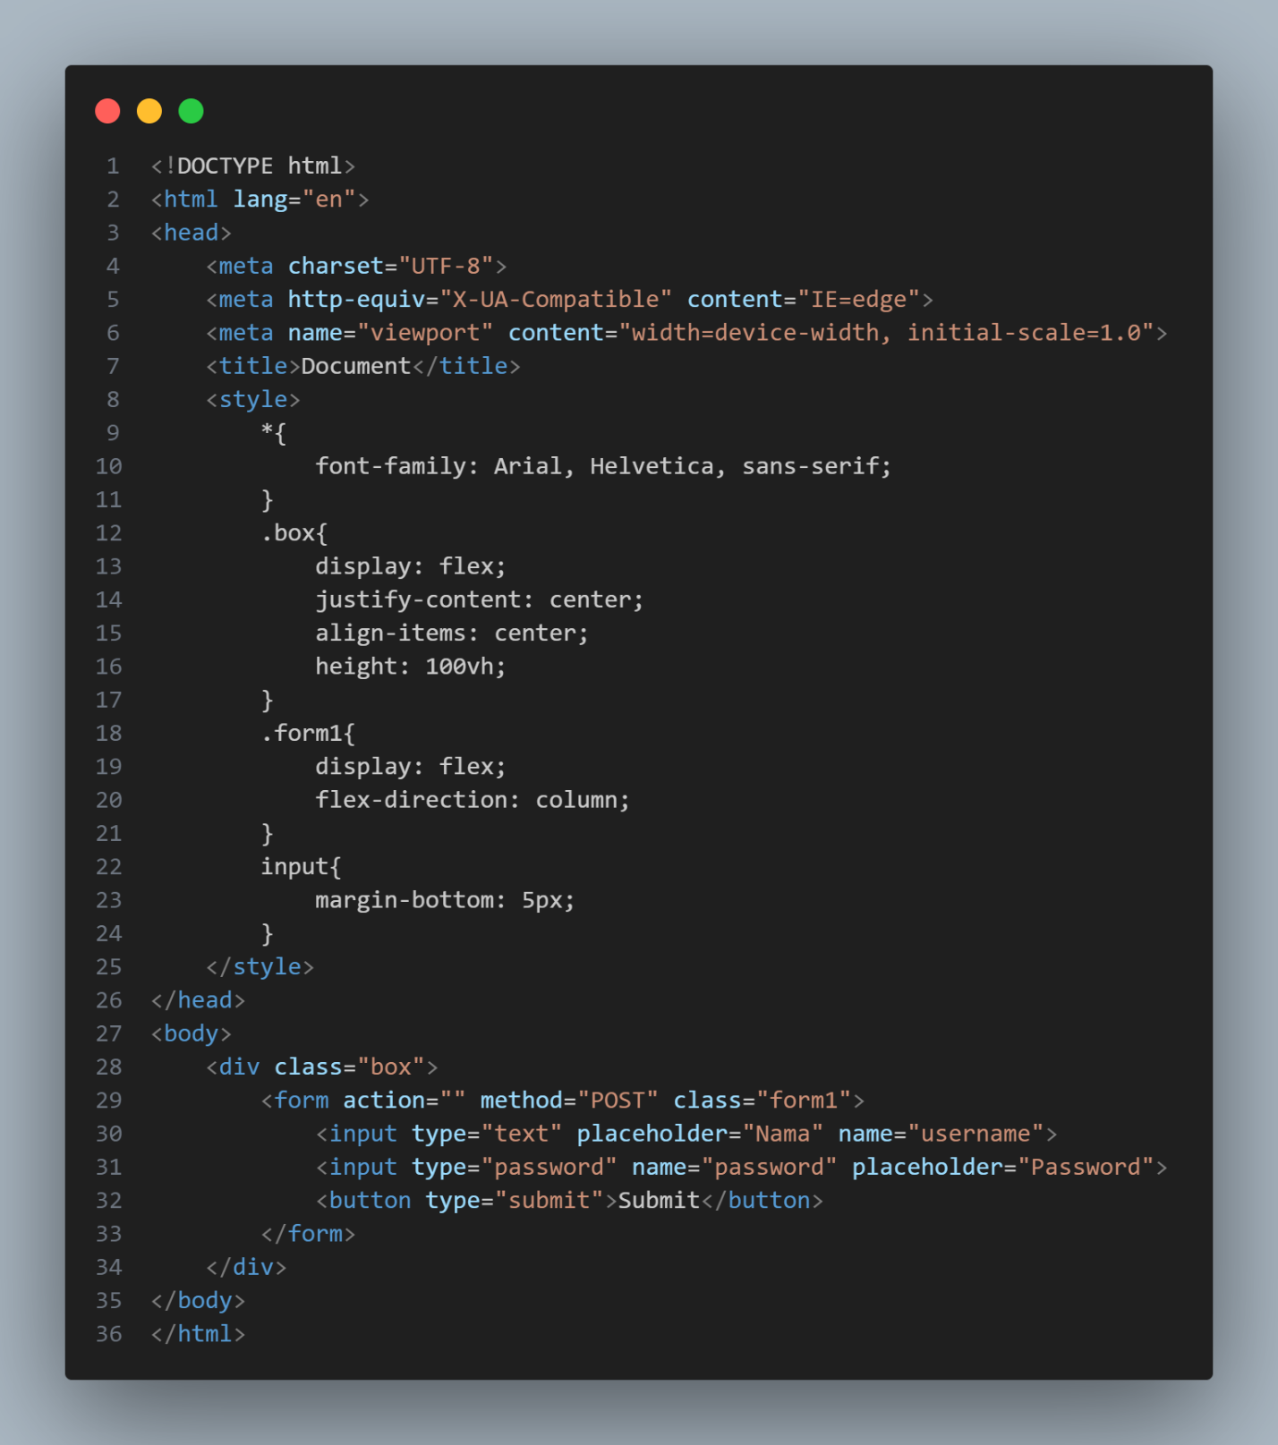

<!DOCTYPE html>

<html lang="en">

<head>

<meta charset="UTF-8">

<meta http-equiv="X-UA-Compatible" content="IE=edge">

<meta name="viewport" content="width=device-width, initial-scale=1.0">

<title>Document</title>

<style>

*{

font-family: Arial, Helvetica, sans-serif;

}

.box{

display: flex;

justify-content: center;

align-items: center;

height: 100vh;

}

.form1{

display: flex;

flex-direction: column;

}

input{

margin-bottom: 5px;

}

</style>

</head>

<body>

<div class="box">

<form action="" method="POST" class="form1">

<input type="text" placeholder="Nama" name="username">

<input type="password" name="password" placeholder="Password">

<button type="submit">Submit</button>

</form>

</div>

</body>

</html>

OUTPUT

